EXP21 DATA PREPROCESSING AND ANALYSIS FOR DATASET USING WEKA
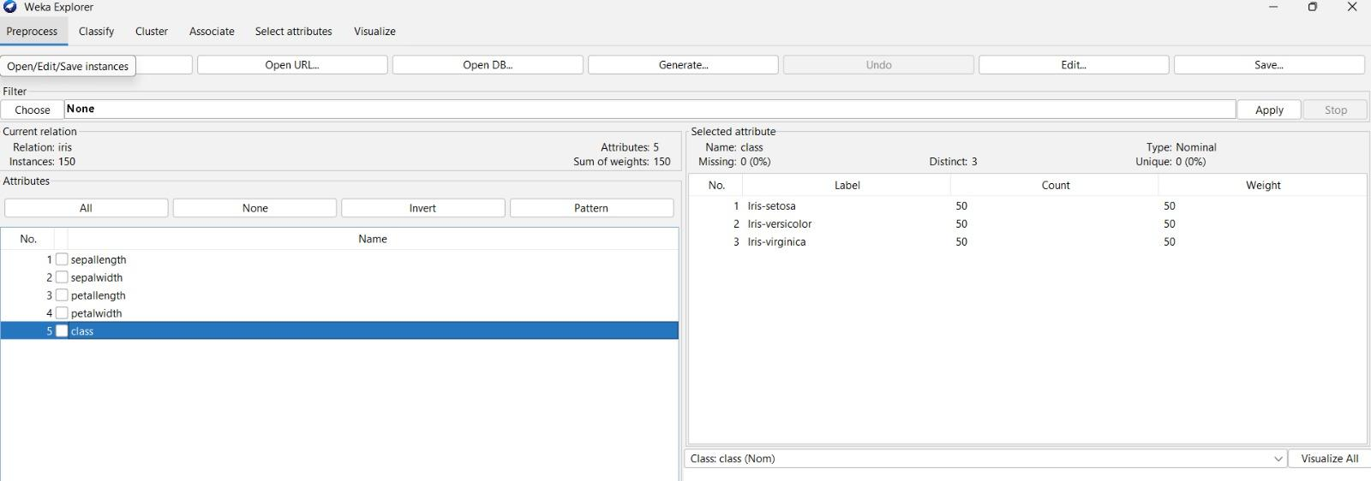

EXP-22 DATA SEGMENTATION BY K-MEANS CLUSTER USING WEKA AND R-TOOL
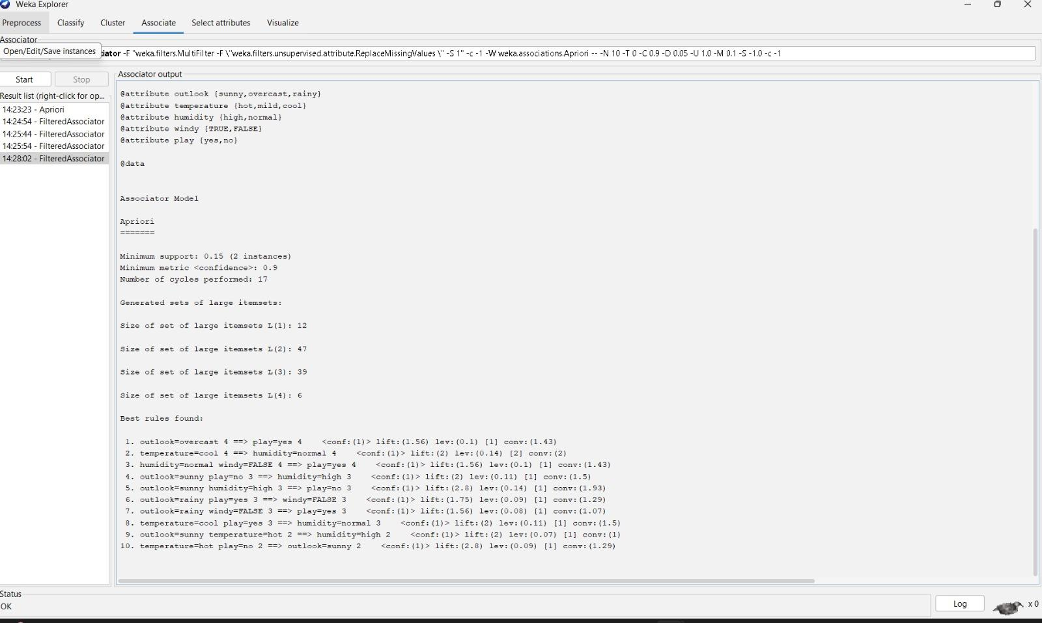

EXPERIMENT- 23 DATA SEGMENTATION BY EXPECTATION MAXIMISATION ALGORITHM THROUGH WEKA

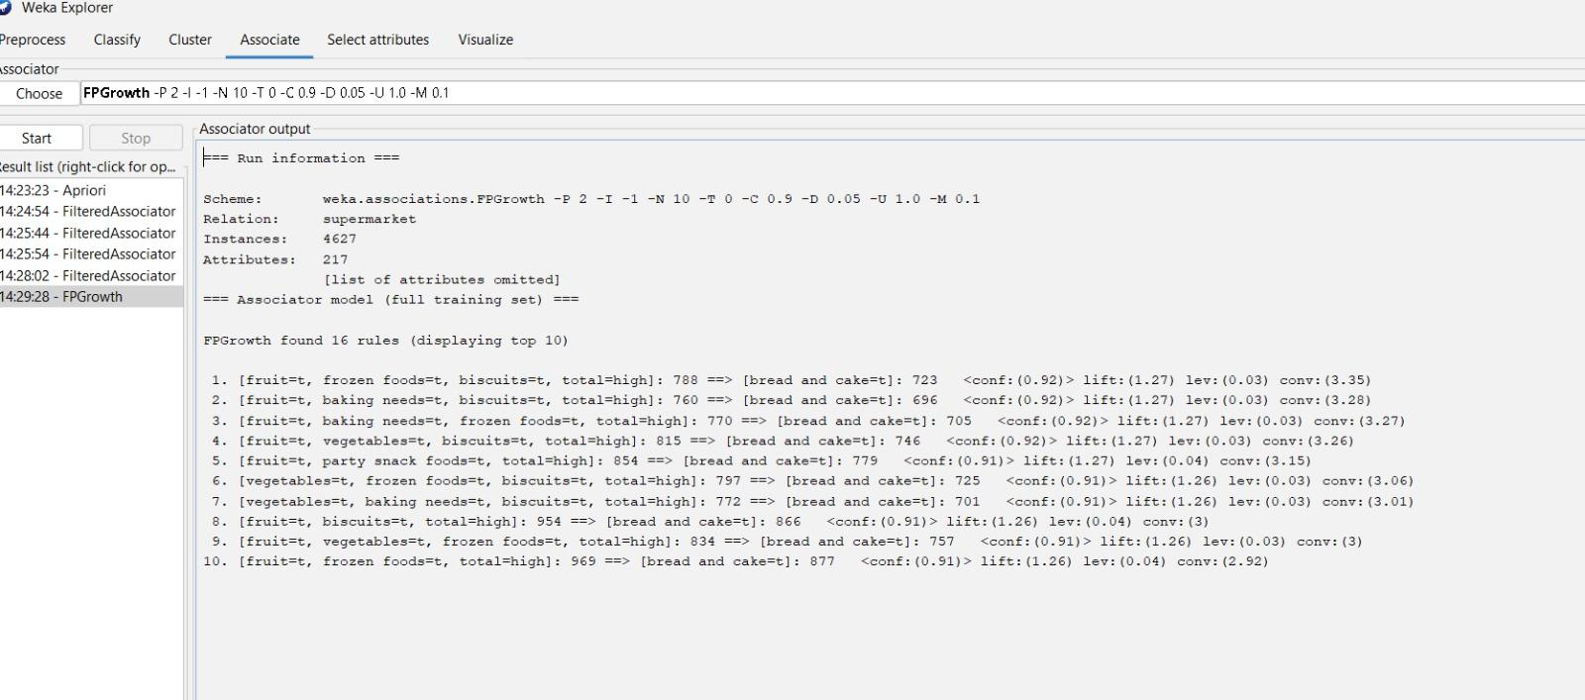

EXPERIMENT- 24 DATA SEGMENTATION BY COBWEB – HIERARCHIAL CLUSTERING ALGORITHM USING WEKA TOOL
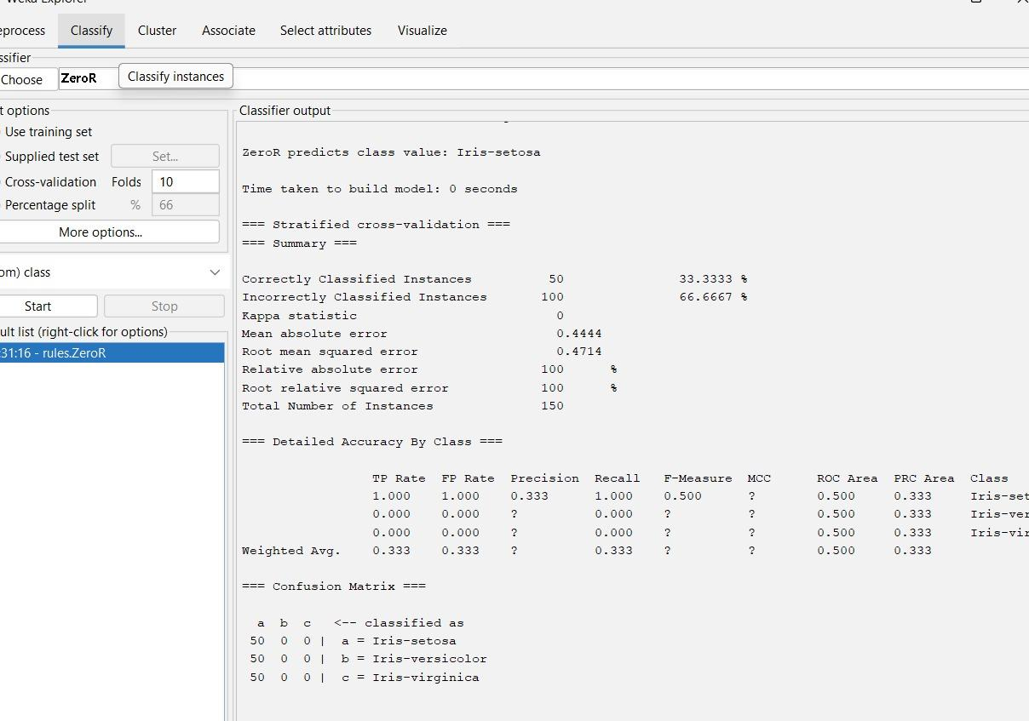

EXPERIMENT- 25 FREQUENT PATTERN MINING USING ASSOCIATION RULE THROUGH WEKA AND R -TOOLS

EXPERIMENT- 26 FREQUENT PATTERN MINING USING FP GROWTH THROUGH WEKA TOOL
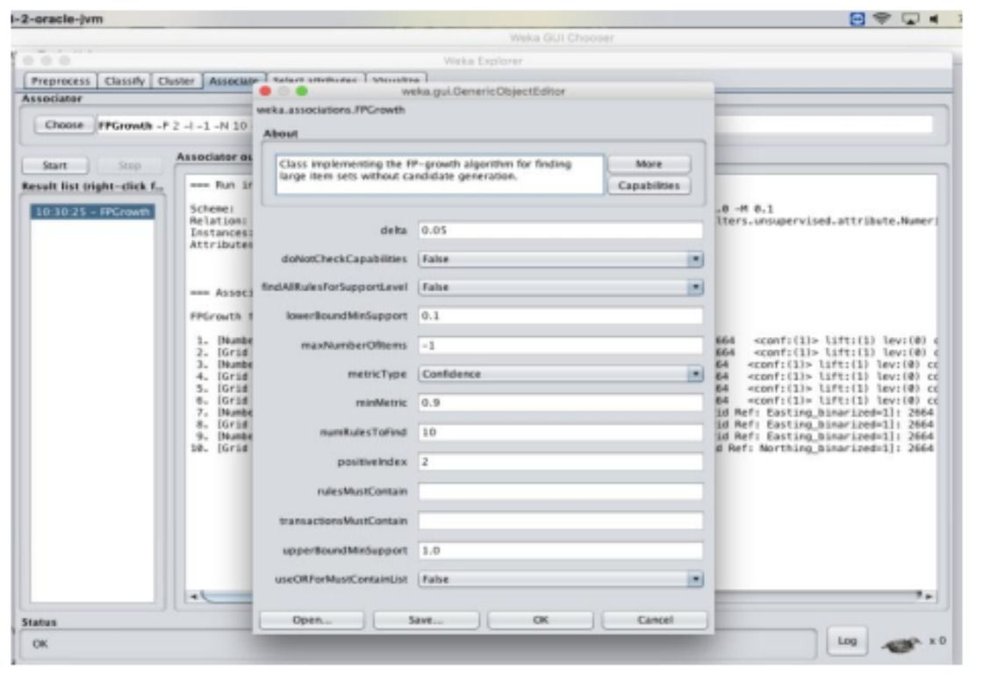

EXPERIMENT- 27 PREDICTION OF CATEGORICAL DATA USING DECISION TREE ALGORTIHM THROUGH WEKA
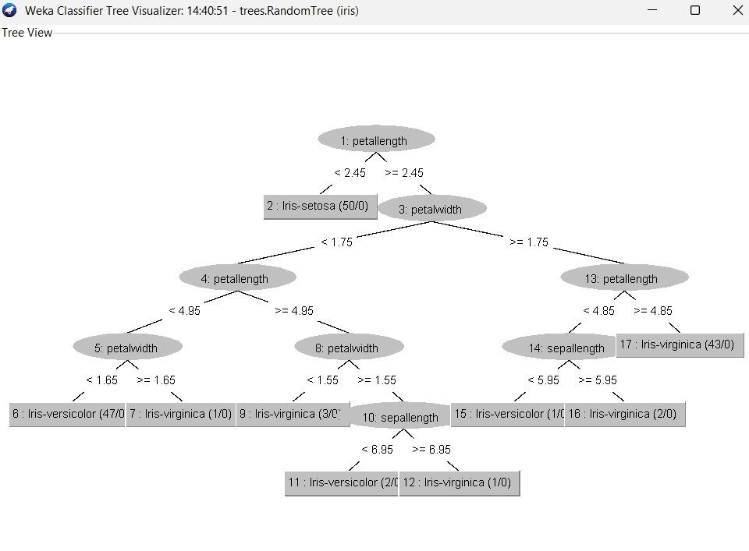
EXPERIMENT- 28 PREDICTION OF CATEGORICAL DATA USING SMO ALGORTIHM THROUGH WEKA


EXPERIMENT- 29 EVALUATING ACCURACY OF THE CLASSIFIERS
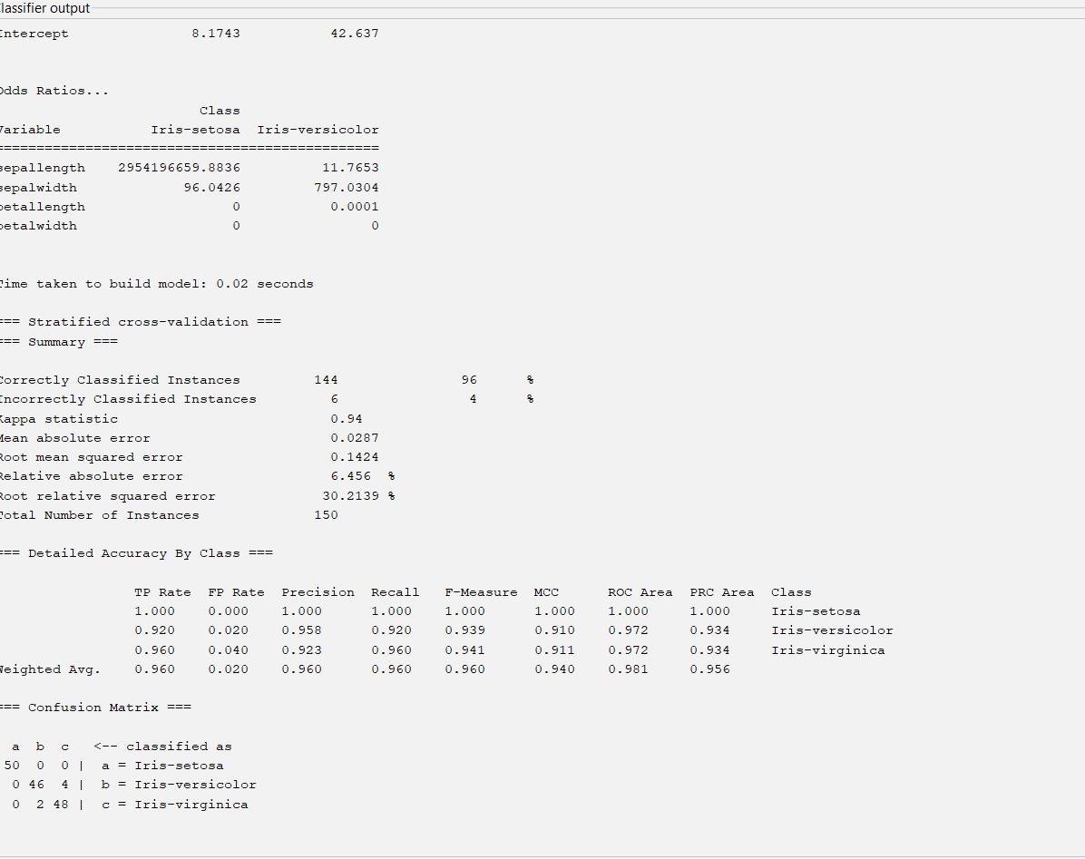

EXPERIMENT- 30 DESCRIPTION NUMERICAL PREDICTION ANALYSIS USING LINEAR REGRESSION THROUGH WEKA

